

**Welcome back to a new school year!** My name is Morgan Henry and I'm the **Box Tops for Education** Coordinator for Barley Sheaf Elementary. Box Tops for Education is a program that gives money to schools for their family’s participation just by purchasing products and scanning the receipt in the Box Tops App. Box Tops earnings are used to help the PTO support our students and staff.



**Last year we earned $445; Our 2024-2025 goal is $500.**

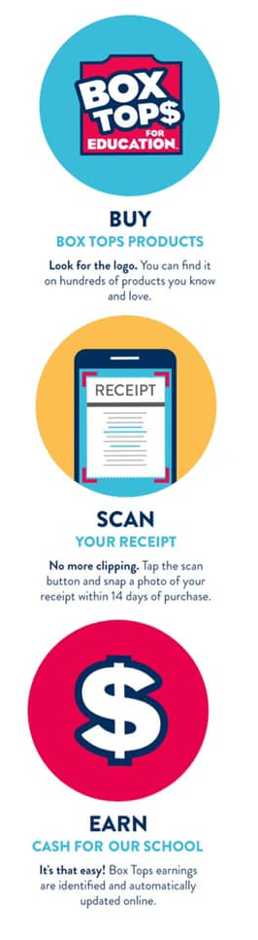

Here's how you can help:

**Download the Box Tops App today** and start scanning – it is an easy task to get used to. Just download the mobile app using the QR Code you see. Register, use **Referral Code B3E48FG7**, and select **Barley Sheaf Elementary School** as your supporting school.

**BUY** Box Tops products, **SCAN** your receipt with the Box Tops app within 14 days of purchase and **EARN** cash with every Box Tops product you buy. Each time you shop (mostly groceries), scan your receipt and if you’ve purchased any participating products, the app will automatically add Box Tops to our school’s earnings AND you can track our school’s progress in real time. If the app misses an item, you can report missed earnings directly in the app.

Remember to SPREAD THE WORD to family, friends, co-workers, & neighbors to SIGN UP for the Box Tops app**,** and SCAN those grocery receipts.

Check the app for bonuses offered. You'll earn Bonus Box Tops for our school when you take advantage of any of the Bonus Offers you see in the app! If you shop online & get an email receipt, just forward your e-receipt to [receipts@boxtops4education.com](mailto:receipts@boxtops4education.com) thru the app and you will get credit.

Turn on notifications in your Box Tops app to get scan reminders and stay updated on special offers, new products, and opportunities to earn for our school. Go to your Communications Settings by tapping on the person icon in the upper-right corner of the app.

Let's work together to give our students what they need to succeed — and see how much we can earn this year! Any questions, contact me at morganhenry5784@gmail.com. I'm here to make sure that this program is a success for our school.